Standard Operating Procedure for
ACTIONS TO ADDRESS RISK AND OPPORTUNITIES
ISO/IEC 17025:2017 – Clause 8.6 and 8.7

Prepared By:  Masab Rasheed | Reviewed By:  Himayat Hussain | Approved By:  Ahmed Umair
AQCM | QCM | CEO
Date: | Date: | Date:

Copyright

The copyright of this procedure, together with all confidential information contained herein is the sole property of QC LAB.
It may be copied in full or in parts only by the Management / personnel and only for the purpose of Company related activities. Disclosure and copying of any information contained within this procedure to any person (s) outside the employee of company without written permission/authorization of the Chief Executive Officer is strictly prohibited.

Amendment Sheet
Date | Revision # | Amendment Detail | Section | DCR | Amendment Approved by
01-10-24 | 01 | Replace issue# with revision# | Header | 13-24 | Chief Executive Officer
01-10-24 | 01 | Deletion of page number from header | Header | 13-24 | Chief Executive Officer
01-10-24 | 01 | QC Lab reporting to CEO for Final Approval | Document Approval | 13-24 | Chief Executive Officer

1.0 Purpose

- To establish and specify systematic steps for corrective action in the resolution of quality related problems.
- To analyze and resolve quality problems in accordance to ISO 17025.
- To create a permanent solution & conduct root cause analysis that prevents recurrence of non-conformance or potential non-conformance.
- To provide a mechanism to deal with customer related problems.

2.0 Scope

This procedure is applicable to all functions in Vital Agri Nutrients QC Lab that can suggest improvement(s) in the system, control nonconformance and implement corrective actions for continual improvement in the Lab Management System.

3.0 Responsibilities
Manager Quality Control is responsible for
- Follow up of corrective action
- Closing of finding after verification of action effectiveness
- To ensure that the CAR forms are properly filled
- Acceptance & rejection of raised CAR's
- To maintain corrective action request log
- To implement corrective actions related to lab within specified time frame
Assistant Quality Control Manager (AQCM) is responsible;
- To initiate the corrective actions against the raised nonconformance.
- To ensure that Corrective actions are implemented.
- To compile the status of corrective actions in the report and submits it to QCM for the management review meeting

4.0 Procedure
4.1 Improvements
All the personnel in the lab are encouraged to identify the opportunities for improvement in their functional areas.
Improvement can be made in the following manner but not limited to:
- Progressive up-grading the Lab Quality objectives and targets
- Initiating corrective actions on problems / NCs
- Giving suggestions for improvement
- Customer feedbacks and complaint.
- Risk Assessment data
- Lab Operations Data Analysis
- Proficiency Testing Data
- Management Review Meeting
- Operational Procedures
Causes of detected/potential non-conformities are promptly identified to develop a corrective action to prevent recurrence/occurrence, as appropriate.
4.2. Initiating Corrective Actions:
Corrective actions are taken to eliminate the root cause to prevent their reoccurrence. Corrective Actions may be initiated but not limited to the following cases:
- Identification of any system / process nonconformity or problems
- Identification of any equipment nonconformity
- Any non-compliance identified during an internal or external audit
- Customer feedback including customer complaints
- Any deviation from defined policies and procedures
- Calibration related issues
- Risk Assessments
4.3. Requesting & Processing CAR's:
    - Any person can initiate CA request on CA Form by filling Section A and deliver it to AQCM or can report the specific situation to AQCM who may initiate a corrective action request by using the corrective action form.
    - AQCM after receiving the CA form ensures that the form has been filled-in properly and then uniquely identifies it by assigning CA number after concerning the CA Log. Following numbering scheme is followed to ensure their unique identification and traceability:
CA Form Number | CA-NN/MM/YY
Where,
CA | Corrective Action
NN | Number starting from 01
MM | Digits representing month
YY | Last two digits of a year, i.e. 2016 as 16.
Note: The CA Form numbering cycle restarts from 1 every month
    - Responsible person is assigned by the QCM to proposed and carry out the corrective actions.
    - AQCM enters the details of the CA form into the CA Log
4.4. Root Cause Analysis:
    - The responsible person (AQCM) in consultation with QCM investigates the causes of the problem. After identifying the root cause, an appropriate corrective action(s) to be taken and indicate the date by which the corrective action will be fully implemented. The investigation process includes:
    - Interviewing the concerned persons and gathering their views about the possible causes of non-conformity (ies)
    - Observing and examining the concerned processes and related records.
    - Examining the supplier for product/services (where required)
    - Make use of statistical techniques, root cause and effect diagram i.e. 4M (Fishbone).

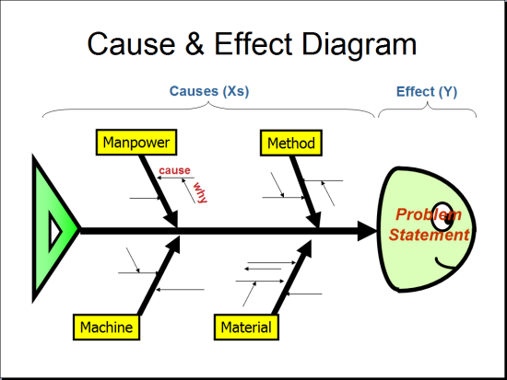

4.5. Implementation of Corrective action
After root-cause analysis, corrective action is suggested, target date and nomination of person for the implementation of suggested action is done. The suggested action after approval of Quality Control Manager is implemented and closely monitored until desired results are obtained.
4.6. Verification of Corrective Action
4.6.1 On, or immediately after, the suggested due date of implementation of a corrective action, Quality Control Manager follows up to determine if the corrective action has been implemented and if it is effective.
4.6.2 When the corrective and measures are found to be effective, they are incorporated in the Lab Management System by making suitable changes in the relevant documents such as specifications, operating procedures, work instructions and Lab system procedures, and the CAR can be closed out. If more work is needed to fully implement the action, a new follow up date is agreed upon.
4.6.3 If, after extension, the suggested corrective and action is still found unimplemented or ineffective then matter is brought to senior management's attention through email / formal letter.

Preventive Actions
    - Preventive actions are taken to eliminate any potential causes of non-conformity. The objective is to provide a mean for detecting any variation in processes, test methods, work standards and systems and thus to prevent the occurrence of a non-conformity.
    - The need for preventive action is brought out by analysis of the following information:
  - Data Analysis which may also include trend and risk analysis
  - Customer’s feedback
  - Unsatisfactory results of proficiency testing (PT)
  - Calibration records
  - Any Other Information
  - Suggestions for Improvement
4.7.3 A preventive action can also be initiated by any person by reporting it on the Preventive action form and submitting it to AQCM as per sub section 4.3 of the procedure. The procedure for processing, implementation and follow-up of preventive actions is the same as described in subsections 4.3, 4.4, and 4.5 above
4.7 Management Review Meeting:
Status of corrective and actions is presented in management review meetings as input. Manager Quality Control compiles the status of corrective actions in the report and submits it in the Management review meeting.
5.0 Related Documents
i. Corrective Action Request Form (QCL-FRM-9.01)
ii. Corrective Action Request Log (QCL-FRM-9.02)
iii. Corrective Action Plan (QCL-FRM-9.03)
vi. Root Cause Analysis Form (QCL-FRM-9.04)

